
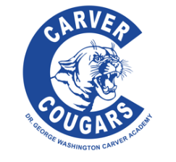
Stronger than ever, year 8, stronger together

Dr. George Washington Carver Academy of Math and Science
Title I Annual Meeting’s
Title I Overview
Title I, Part A is intended to help ensure that all students have the opportunity to obtain a fair, equal, and significant opportunity to obtain a high quality education and reach, proficiency on challenging state academic achievement standards and assessments.
Each school determines how to allocate Tittle 1 funding. Funds can be used to improve curriculum and program, instructional activities, counseling, parental involvement, increase staff, etc. The funding has one goal and that is to assist schools in meeting the educational goals of at risk or low-income students.
School-wide programs serve all children in a school. All staff, resources and classes are part of the overall school wide program. The purpose is to generate high levels of academic achievement in core subject areas for all students, especially those students most in need. This purpose is achieved through: high quality instruction; comprehensive reform strategies and methods that are based on the use of scientifically based research; strategies.
Wednesday, August 30th, 2023 at 4:30 p.m. till 6:30 p.m.

Parents/ guardians, students and staff your feedback is needed. EVERYONE WHO ATTENDS the meeting will be entered into a drawing for a Gift Basket. The raffle will be held on Friday, September 15th, 2023, at Noon. Winning number will be posted on School Website and announced at school. Present raffle ticket to Parent Coordinator to obtain Basket.

