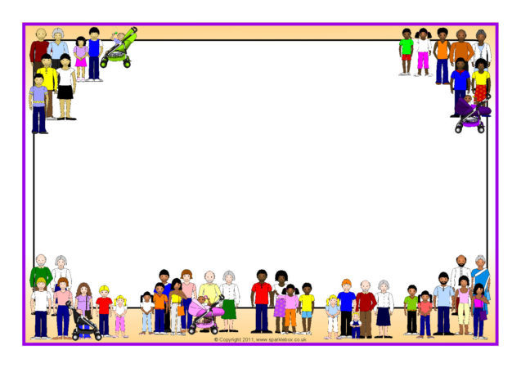
Virtual District Advisory Council Meetings
6 pm
November 2nd
December 7th
January 4th
February 1st
March 2nd
April 4th
May 2nd
We wanted to reach out to let you know that we value your opinion and want to hear your voice. We have an upcoming event where we'll be discussing important topics that affect our community, and we believe your insights would be incredibly valuable.
Here’s the link: https://milwaukeemps.zoom.us/j/89791600841?pwd=a2x2YUFGbHMxcFRxYzZ0L084eTNhdz09

